

ITECX International Congress on Technology, Education and Contemporary Sciences

[Congress edition or full name] | [Dates] | [City, Country]

[Full Paper Title in English]
[First Author¹], [Second Author²] and [Third Author²*]
¹ [Department or School, Institution, City, Country]
² [Department or School, Institution, City, Country]
*Corresponding author: [Full name] | [Email address]
ORCID iDs: [Author name and ORCID, if available]

ABSTRACT
[Replace this text with a concise, self-contained abstract. State the background or problem, the aim, the methodology or project approach, the main findings or outcomes, and the conclusion. For a review, explain the scope and main synthesis. Define essential abbreviations and avoid citations unless necessary. Follow the abstract length specified in the congress call.]
Keywords: [Keyword 1]; [Keyword 2]; [Keyword 3]; [Additional keywords if required]

USING THIS TEMPLATE
Replace all bracketed text and delete all instructional paragraphs before submission. Keep the title, author details, abstract, keywords and relevant paper sections. These page breaks organize the template only; remove them as needed, except for the new page before References.
Layout: A4, 2.54 cm margins, single column. Main text: Times New Roman, 12 pt, 1.5 line spacing, justified, no first-line indentation. Title: 12 pt bold, centered. Author names: 11 pt bold, centered. Abstract and keywords: 10 pt. Use the built-in Word heading styles.
Adapt section names to the study type. Review papers may use review methods and thematic synthesis; engineering or design papers may use design, implementation and evaluation. Follow the congress call for language, length and submission requirements.

1. INTRODUCTION
[Introduce the topic and its context. Explain the research problem or practical need, summarize the most relevant literature, and identify the gap addressed by this paper. End with the purpose and scope of the study or project.]

1.1 Aim and Research Questions
[State the aim and the research questions, hypotheses or design objectives. Use only the categories relevant to your work. Explain the contribution the paper makes.]

2. METHODOLOGY
[Explain the research design or technical approach and justify its suitability. Describe the process clearly enough for readers to understand how the evidence or outcomes were produced.]

2.1. Participants Materials or Data Sources
[Describe the sample, study setting, materials, equipment, datasets or documents. Explain selection criteria and relevant characteristics. For a review, identify databases, search terms, eligibility criteria and the search period.]

2.2. Procedure and Analysis
[Describe data collection, instruments, implementation steps and analysis methods. For an engineering project, explain the design, prototype or system and the testing criteria. Report software and versions where relevant.]

2.3. Ethical Considerations
[Where relevant, describe approval, consent, privacy safeguards and permissions. For research involving children, describe guardian consent and participant assent as applicable. Do not claim approval or consent that was not obtained. If not relevant, remove this subsection.]

3. FINDINGS OR RESULTS
[Present the findings in the order of the research questions or objectives. For design projects, report implementation and evaluation outcomes. Distinguish measured results from expected outcomes. Refer to each table and figure in the text and avoid repeating all their contents.]
Table 1.
Distribution of Participants by Department, Academic Level, and Study Mode
Department | Undergraduate |  | Graduate |  | Total
Department | Full Time | Part Time | Full Time | Part Time | Total
Computer Eng. | 18 | 6 | 9 | 4 | 37
Business Adm. | 15 | 8 | 11 | 5 | 39
Educational Sci. | 21 | 7 | 8 | 6 | 42
Total | 54 | 21 | 28 | 15 | 118

Note: The values presented in the table are illustrative and should be replaced with the actual data of the study.

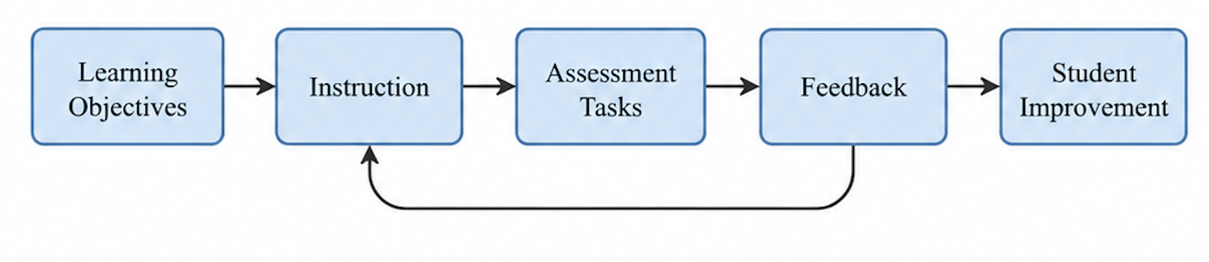
Figure 1
Conceptual Framework of the Student Assessment Process
(Figure title: Times New Roman, 12-point, italic, left-aligned, sentence case.)

4. DISCUSSION
[Interpret the findings in relation to the aim and previous work. Explain their significance, practical or theoretical implications, and limitations. Avoid claims that go beyond the evidence.]

5. CONCLUSION AND RECOMMENDATIONS
[State the main conclusion and contribution. Offer recommendations supported by the findings and identify useful next steps or future research. Do not introduce new results.]

DECLARATIONS
Complete the statements relevant to your paper. Replace the prompts with accurate statements. Use “Not applicable” only where appropriate; follow any additional congress requirements.
Author Contributions [Describe each author’s contribution. For a single-author paper, state the author’s responsibility for the work.]
Acknowledgements [Acknowledge mentors, technical assistance or other support not listed as authorship or funding. Remove if not applicable.]
Funding [Identify the funder and grant number, or state that the work received no external funding, if accurate.]
Conflicts of Interest [Disclose relevant interests, or state that the authors declare no conflicts of interest, if accurate.]
Ethics and Consent [Provide the committee name and approval reference, and relevant consent information; cross-reference Section 2.3 where applicable. Otherwise explain why approval and consent were not applicable.]
Data and Materials Availability [Explain where supporting data or materials can be accessed, or describe restrictions. Do not include identifiable participant information.]

REFERENCES
Use APA 7 consistently for citations and references. Include only works cited in the paper and ensure every citation has a matching reference. Arrange entries alphabetically by the first author’s surname. Use DOI URLs where available. Replace the structural examples below with complete references.
In-text citation examples: (Author, Year); Author (Year); (Author & Author, Year). For three or more authors, use (Author et al., Year) from the first citation. Add a page number or other locator for a direct quotation.
Author, A. A., & Author, B. B. (Year). Title of the article. Journal Title, volume(issue), xx–xx. https://doi.org/[DOI]
Author, A. A. (Year). Title of the book. Publisher. https://doi.org/[DOI if available]
Author, A. A. (Year). Title of the chapter. In E. E. Editor (Ed.), Title of the book (pp. xx–xx). Publisher.
Author, A. A. (Year, Month Day–Day). Title of the presentation [Paper presentation]. Congress Name, City, Country.
Organization Name. (Year, Month Day). Title of the webpage. Site Name. [URL]
Reference examples are structural placeholders, not sources. Italicize journal titles and volume numbers, book titles, and standalone work titles as appropriate. Omit unavailable elements and do not invent bibliographic details. Do not add a DOI, ISBN or journal identifier to the paper header; publication metadata are supplied by the organizers.

